Lesson 05 Demo 03

Creating DNS Zones

Objective: To create a DNS zone and a record for user's domain
Tools Required: Azure account with administrator access

Prerequisites: None

Steps to be followed:
- Create a DNS Zone
- Add a DNS record set

Step 1: Create a DNS Zone

- Login to the Azure Portal, search for DNS zones, and click on Create dns zone. Add the details in the Basics tab, and then click on Review create> Create

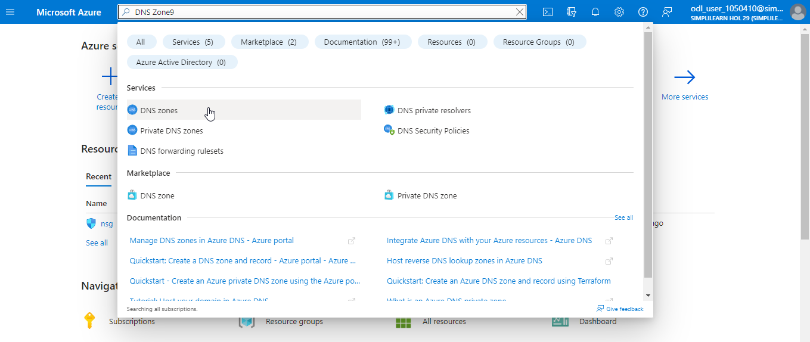

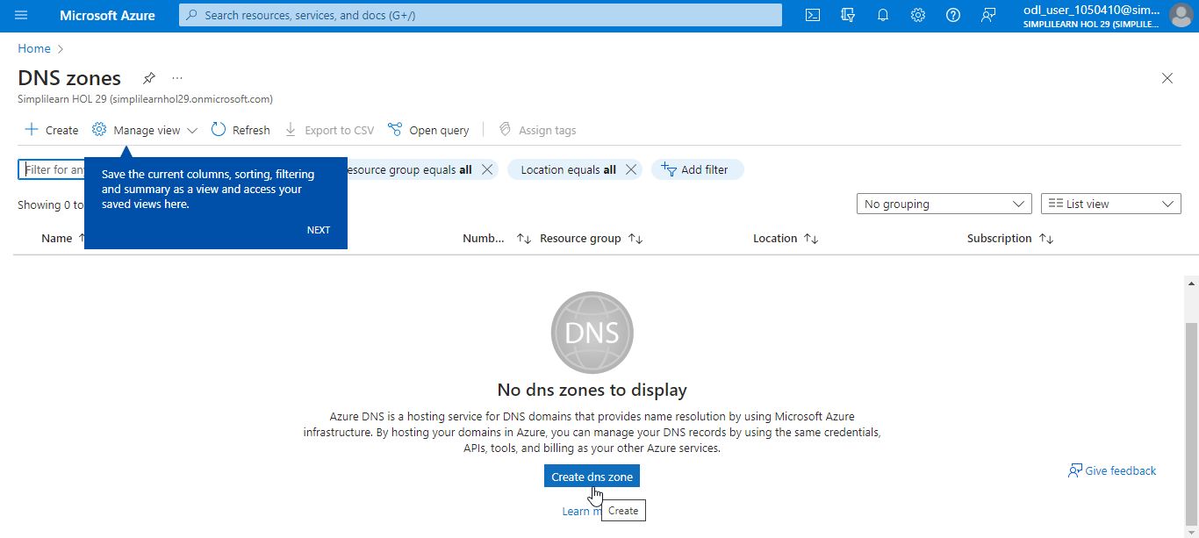

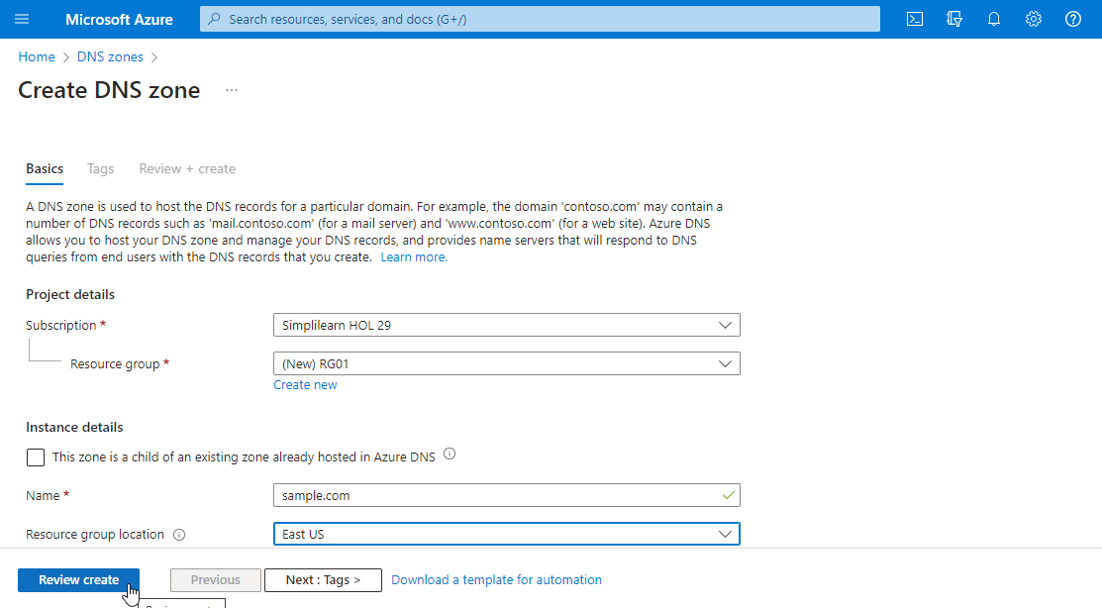

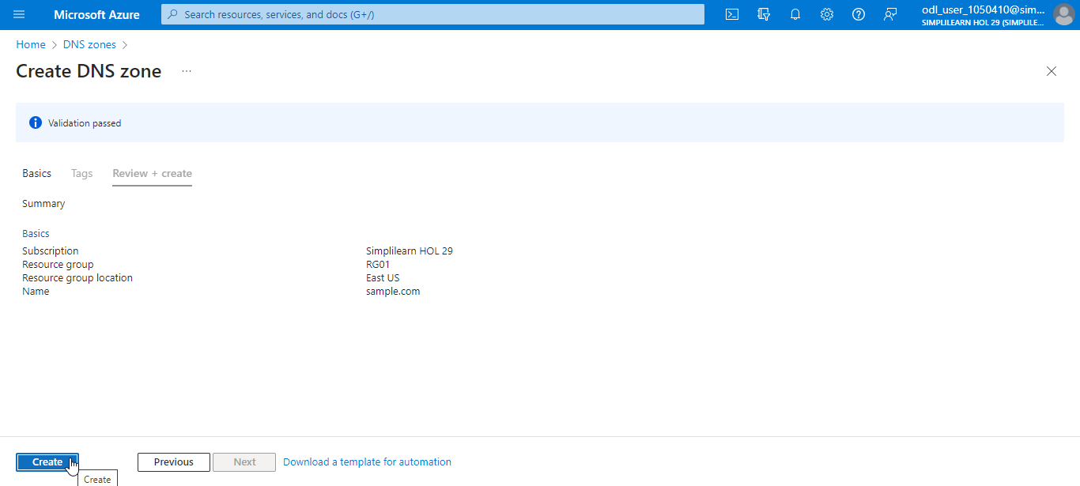

Step 2: Add a DNS record set

  - Click on Go to resource. Under DNS zone, click on Record set, add the details for Name and Type under Add record set, and click on OK

Note: The IP address changes based on the specific requirements Type

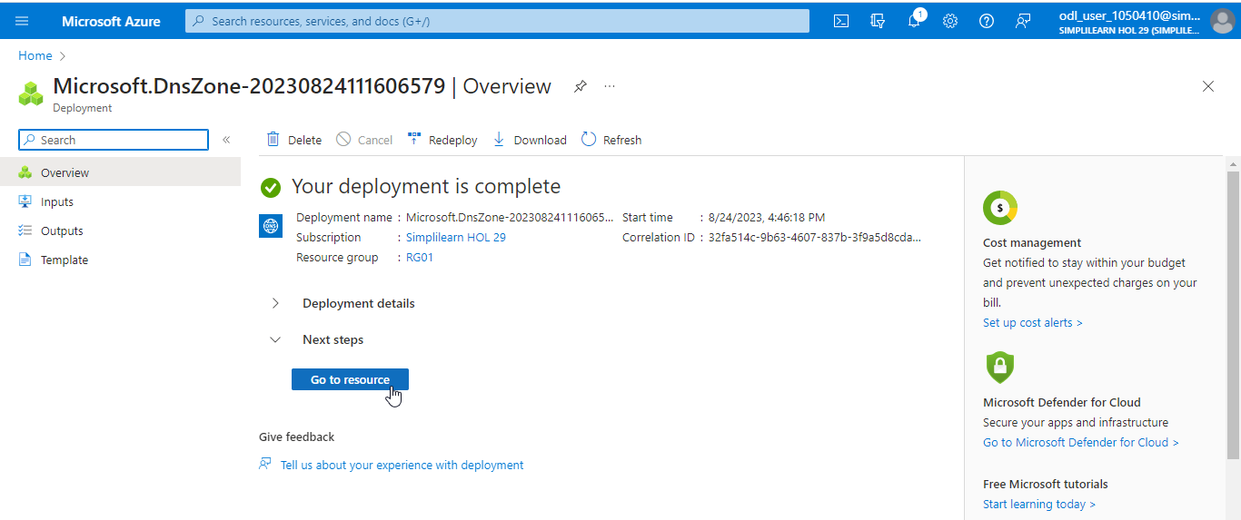

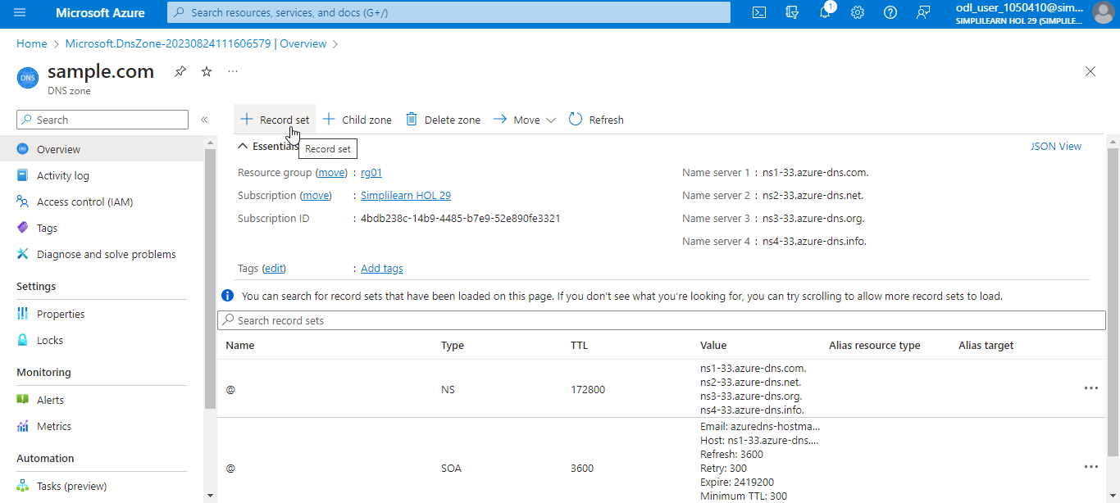

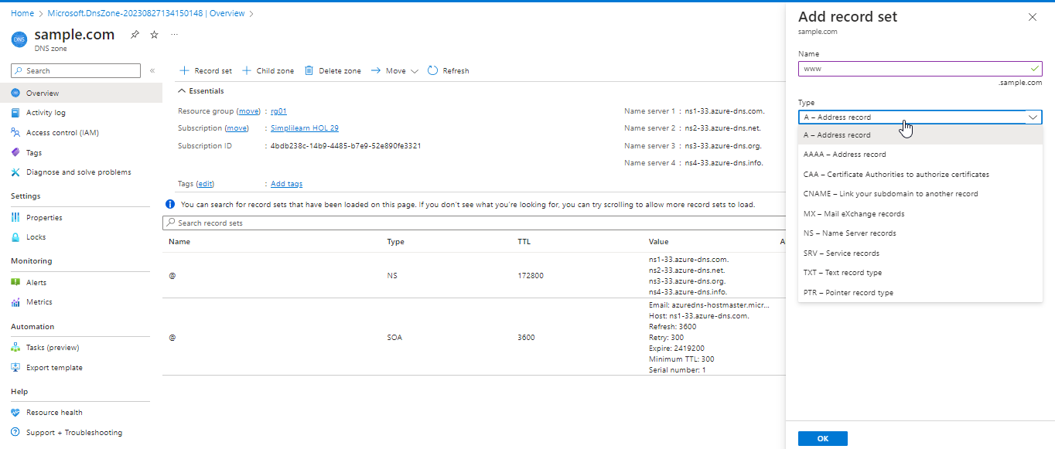

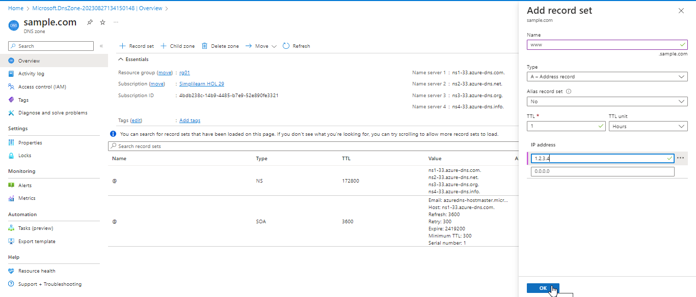

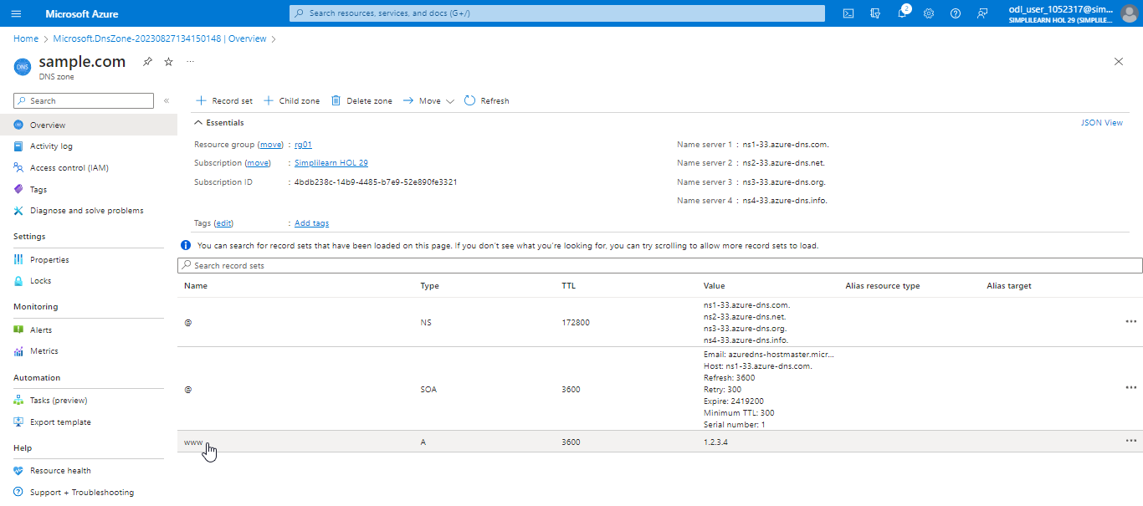

With this, you have successfully created the DNS zone and a DNS record to make the user's domain internet routable.

